VPC Experiment

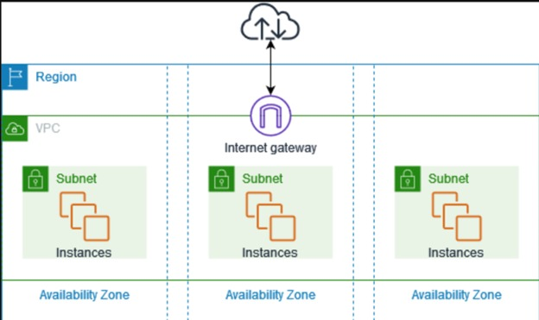

Navigate to VPC dashboard.

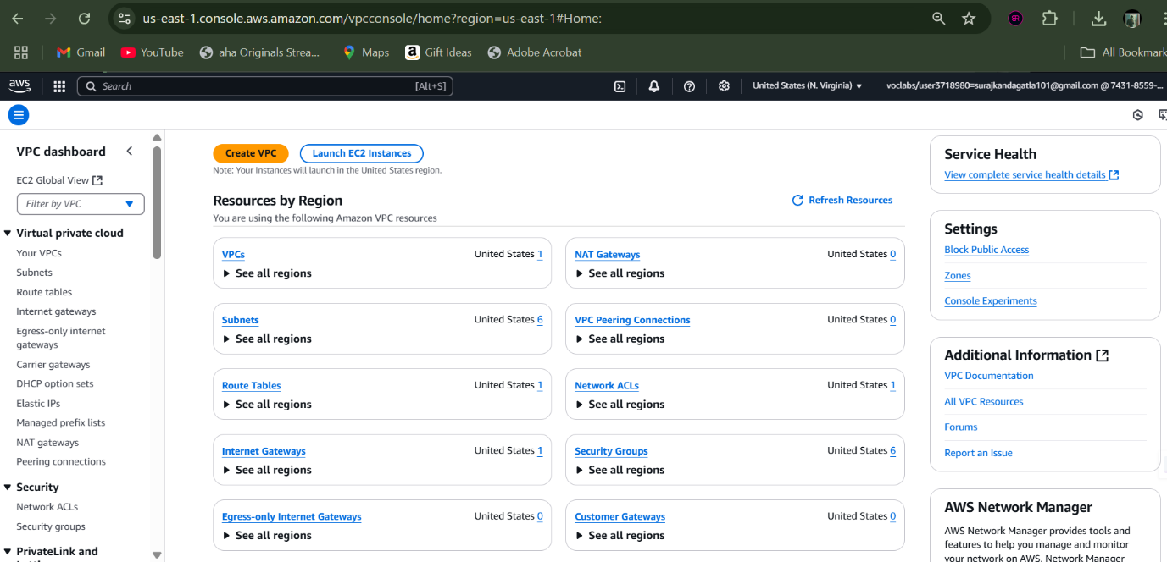

Create a VPC with custom name and IPv4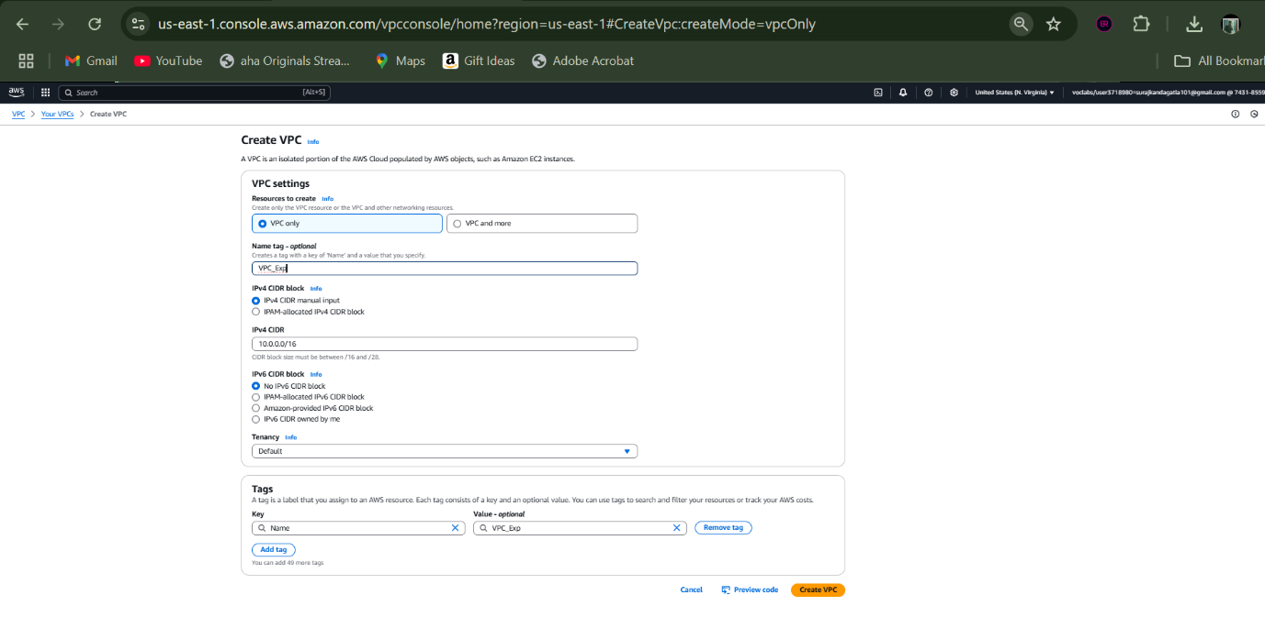

Now head to subnets section and create two subnets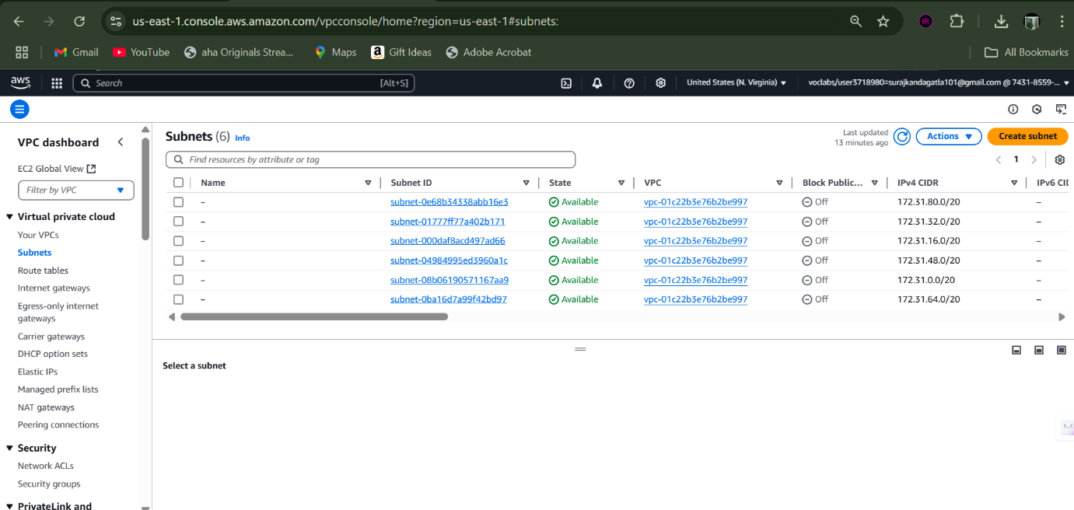

This Is a public subnet for web server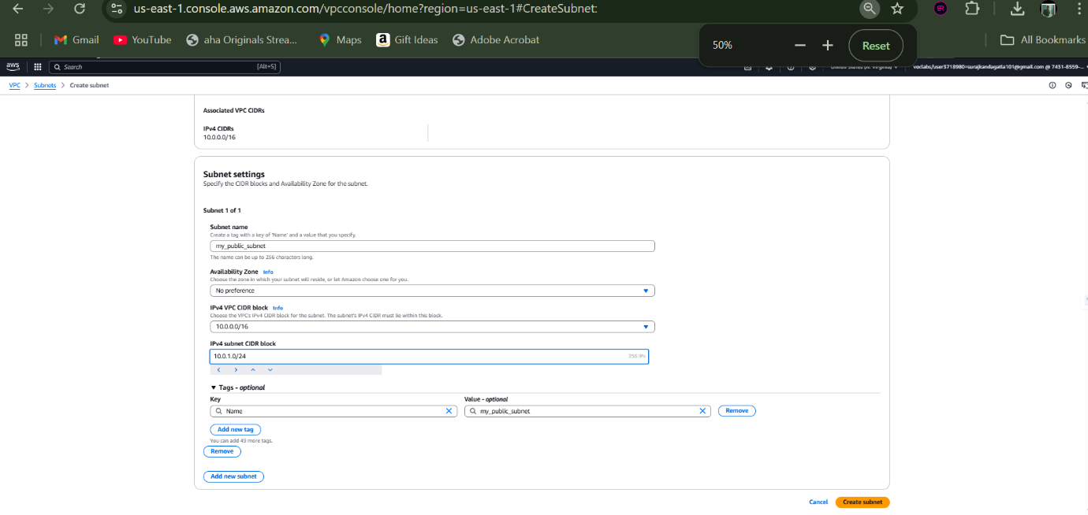

This is a private subnet for DB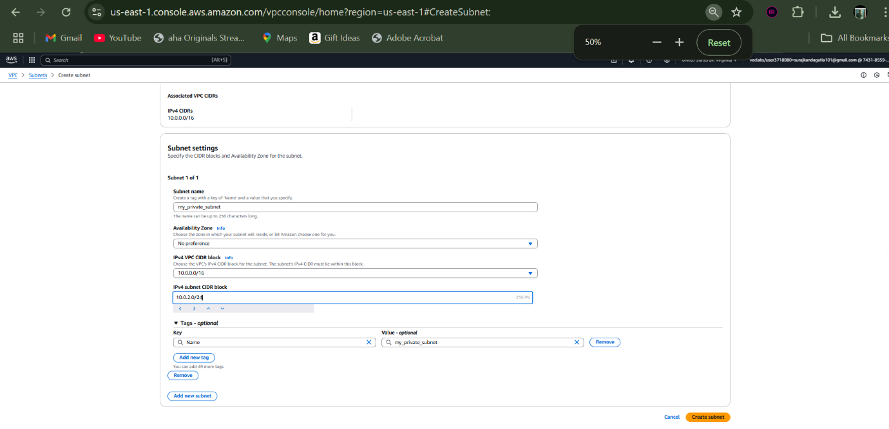

Now we are creating a Internet Gateway: provide a name to it.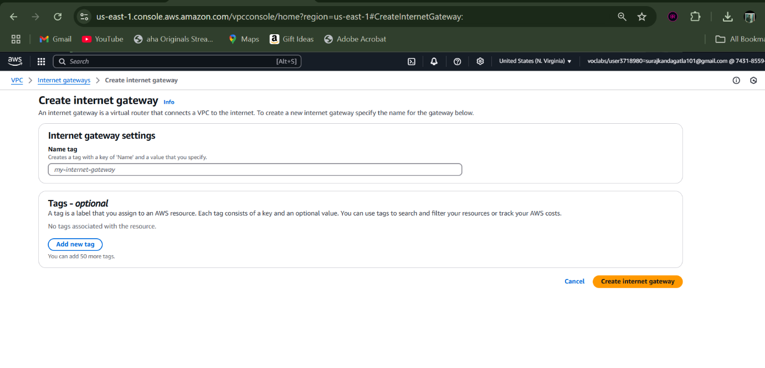

Then create a Route Table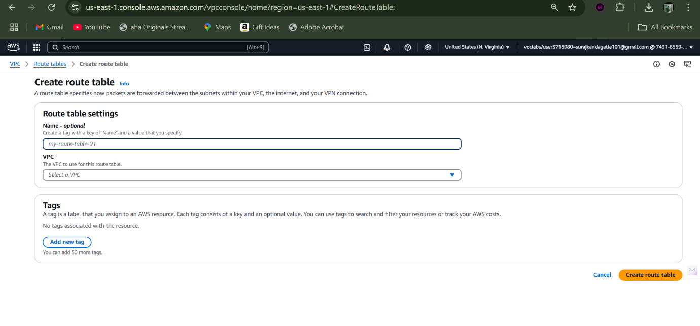

Now we should edit routes for that and add a rule.

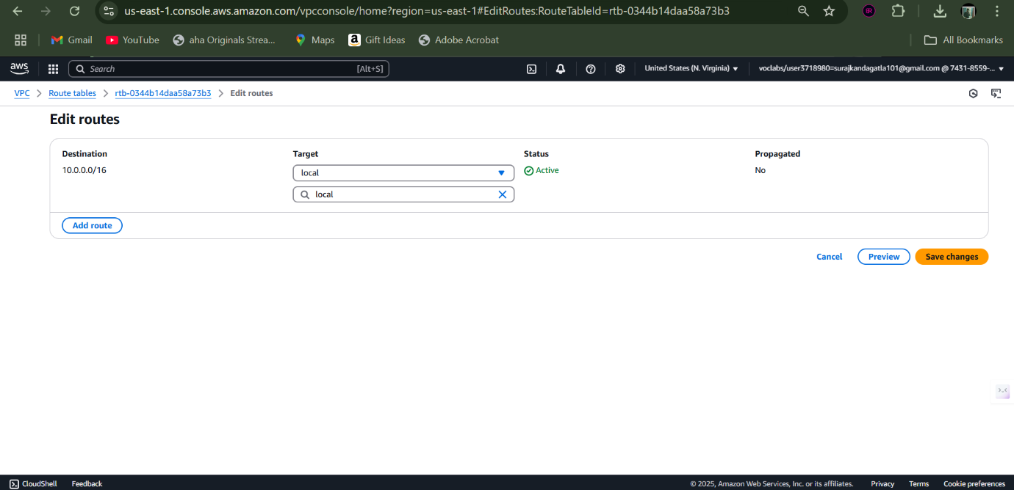

i.e add Internet Gateway and provide your gateway.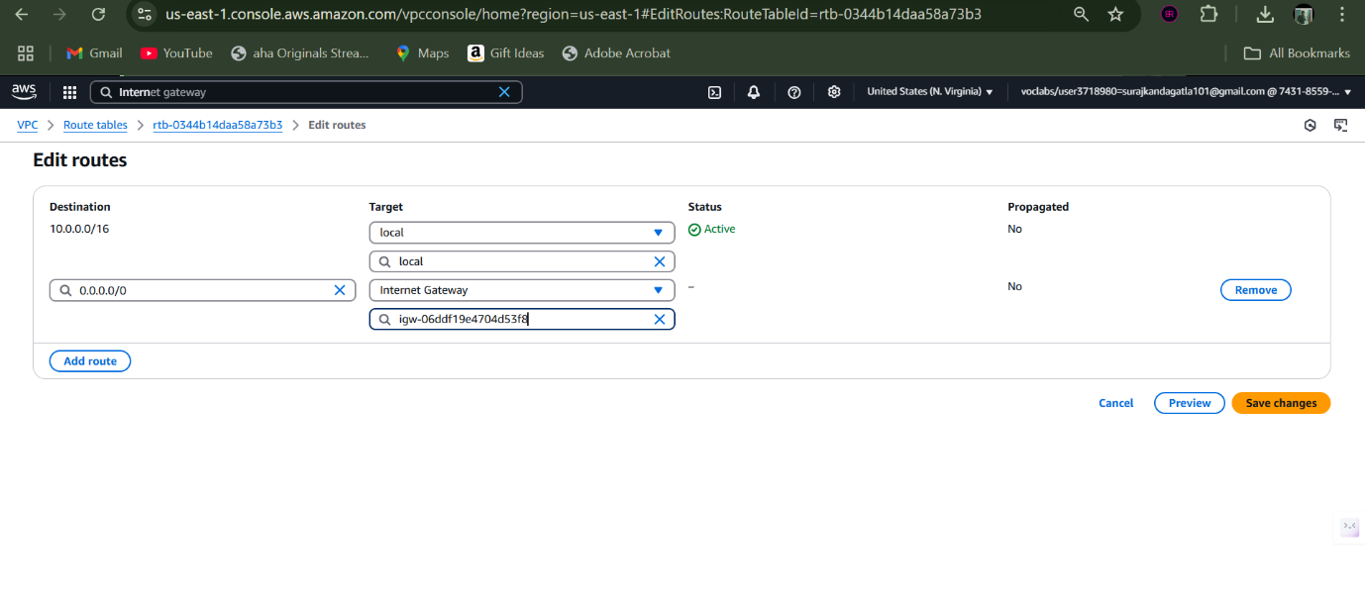

now we should connect our VPC to our gateway.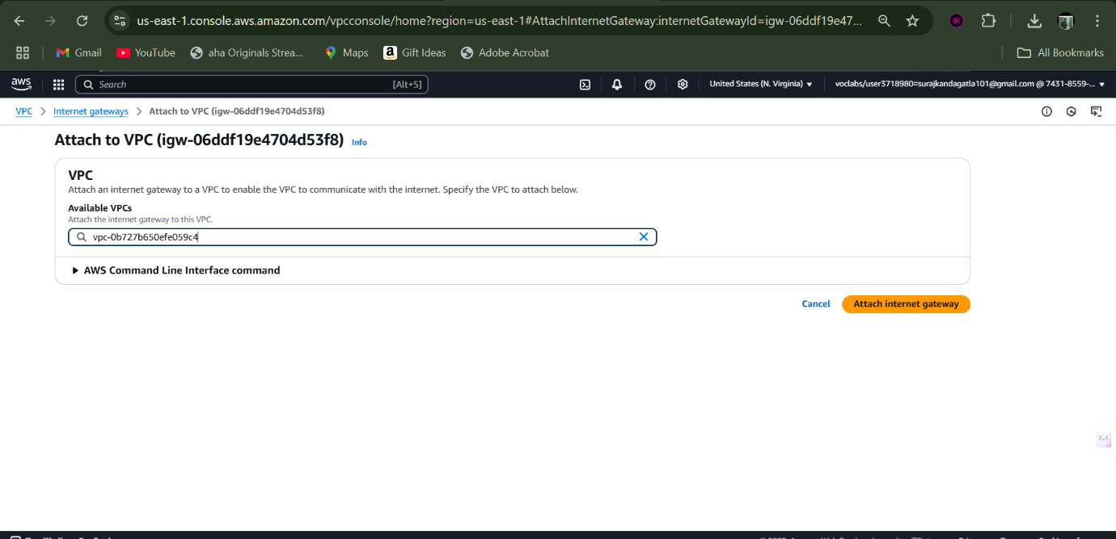

under route actions go for “edit subnet associations”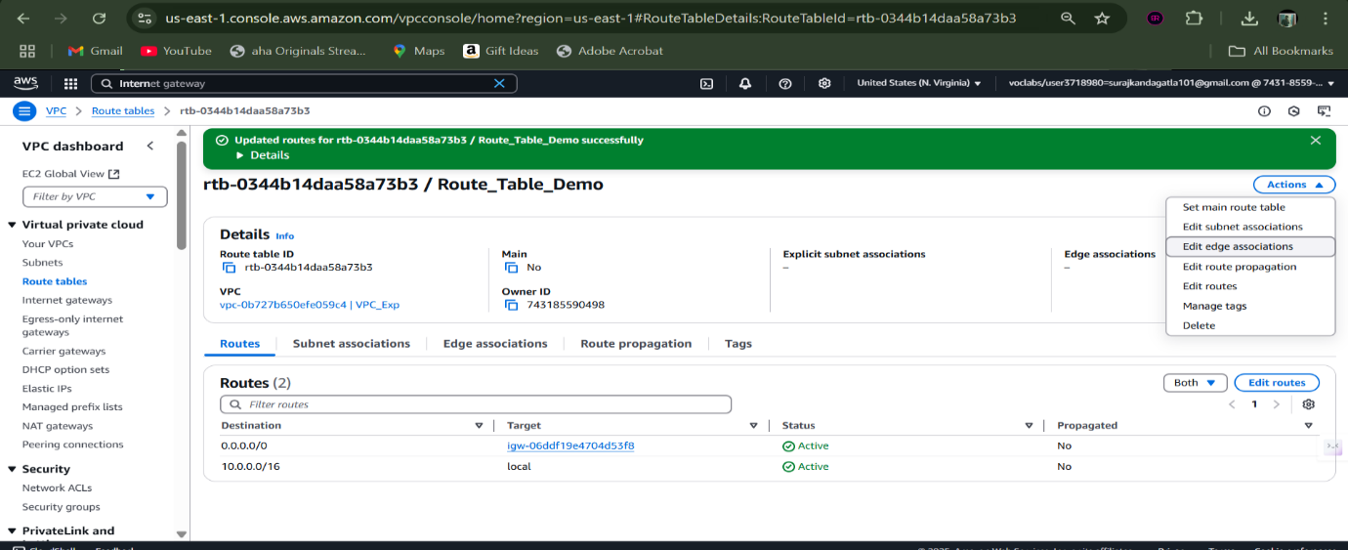select your public subnet and save the association.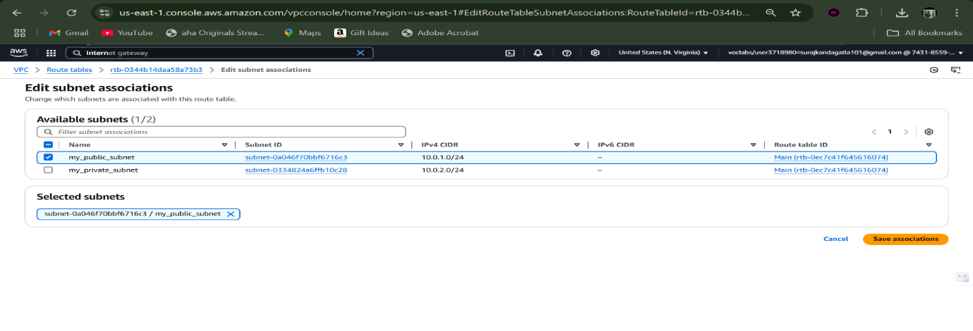

->create an EC2 instance for webserver and write the code under Additional Details.

#!/bin/bash

sudo su

yum update -y

yum install httpd -y

cd /var/www/html

echo "MyGoogle" > index.html

service httpd start

chkconfig httpd on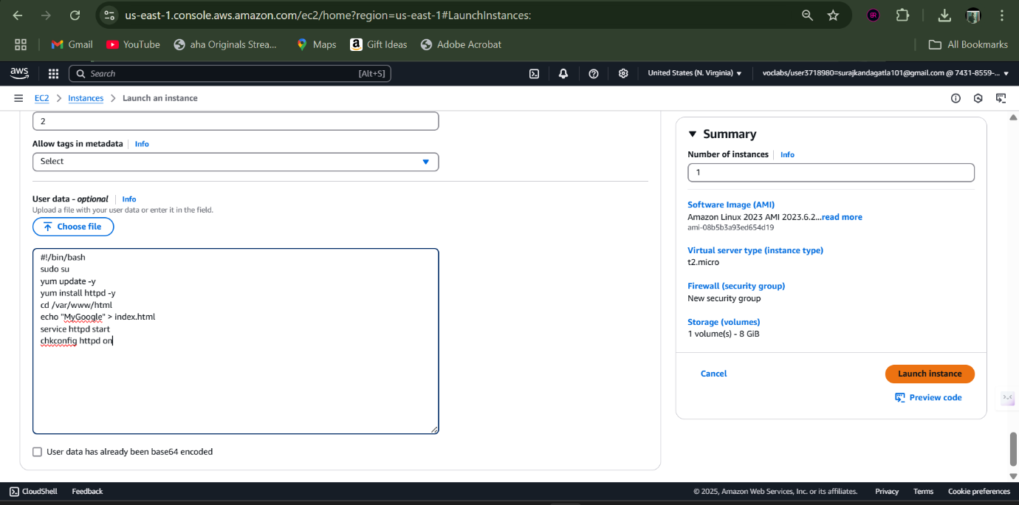

create an EC2 instance for DB server and write the code under Additional Details (same as previous). 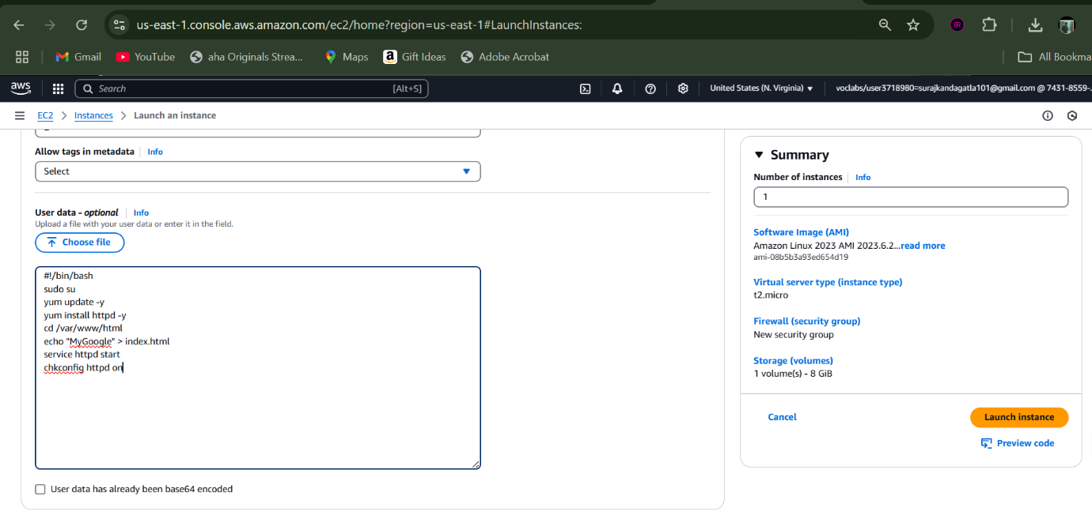

now we can access our web server instance using its public IPv4 address.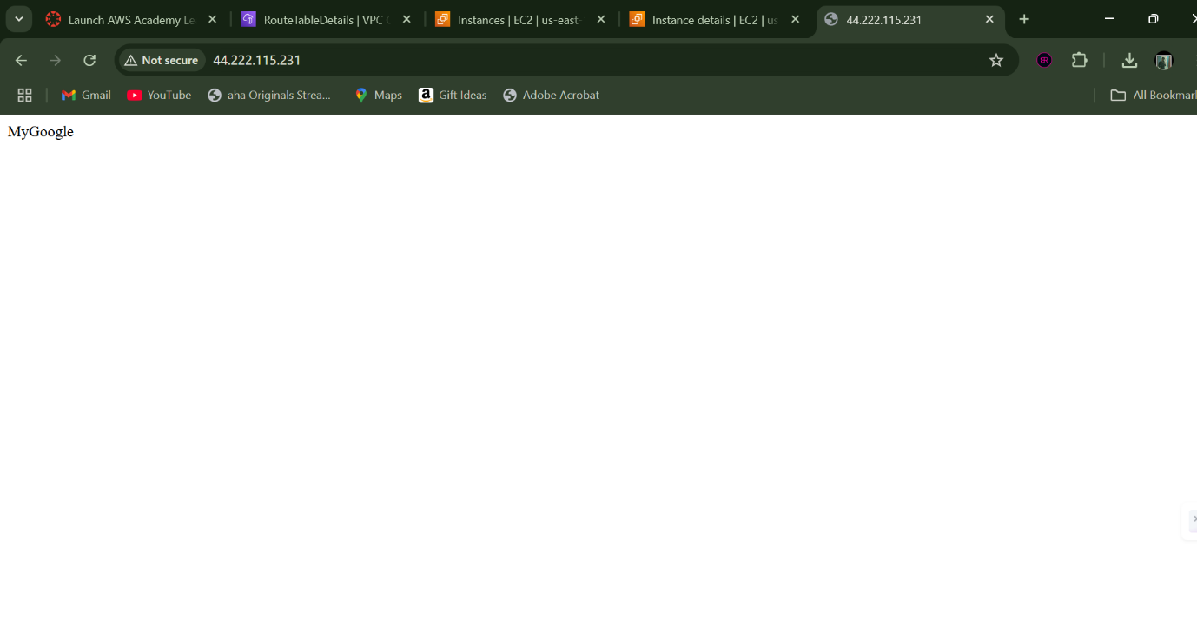

we can also ensure that the DB instance doesnot have any public IPv4 address.